Applications of Surface Integrals; Flux Worksheet

- Let be the portion of the cylinder between the planes andoriented by outward normal. Compute the flux of F across, where .

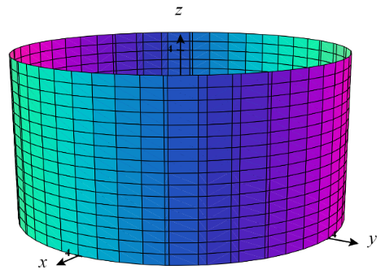
We see that we cannot write this surface as a function and therefore we must approach this question by viewing the surface parametrically.

We create a parameterization for :
where .
We calculate that:
Therefore,

Now, we have that,

- Let be the portion of the plane in the first octant oriented by upwards normal and . Compute the flux of F across in the positive direction.
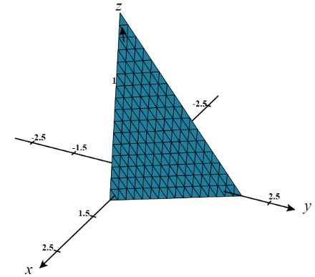
Since represents the graph of a function of the form , specifically , we do not have to find a parameterization for and instead we tackle the problem as follows.

We note the function and therefore we have that:

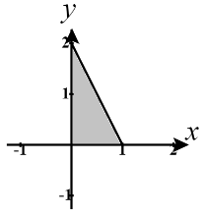
The region D is the projection of the solid into the xy-plane as shown in the picture to the right.

Therefore, we have that:

- Let be the portion of the paraboloid below the plane oriented by inward normals and . Compute the flux of F across in the direction of orientation.
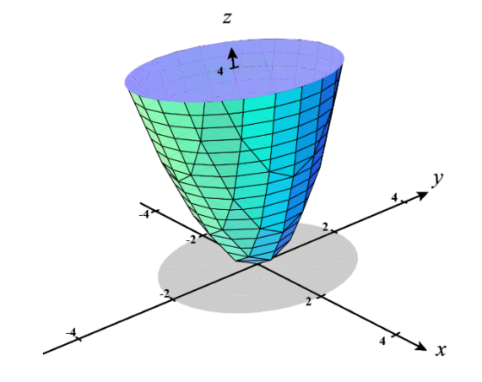
Since represents the graph of a function of the form we do not have to find a parameterization for and instead we tackle the problem as follows.

We note the function and therefore we have that:

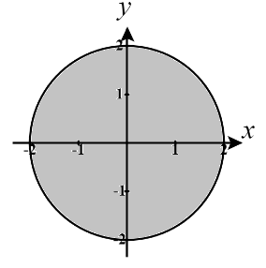
The region D is the projection of the solid into the xy-plane as shown in the picture to the right.

Therefore, we have that:
Note: This result the opposite of the result we obtained on Example 5 in section 5.6. This is not surprising since we have simply changed the orientation of the normal vectors.
- Let be the portion of the sphere that is inside the cone and . Find the flux of F across with respect to upward normals.
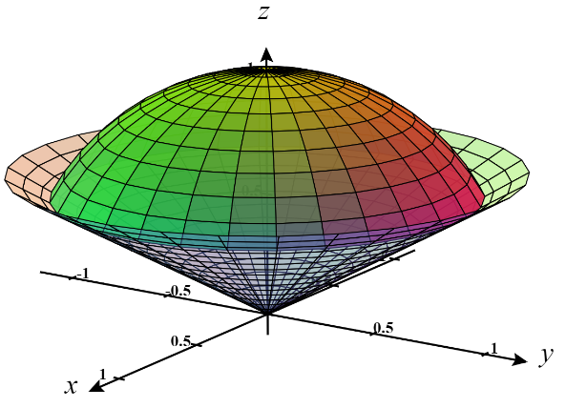
We see that it will be difficult to write this surface as a function and determine appropriate bounds on x and y. Therefore, we must approach this question by viewing the surface parametrically.

We create a parameterization for using our knowledge of spherical coordinates:
where . (work may need to be done to demonstrate bounds on as done in section 4.6.2).
We calculate that:
Therefore,
Since we are working with upward facing normal and the z-component here is negative, we must use
Now, we have that,
- Let . Find the inward flux of the surface that is bounded by the paraboloid and the plane .

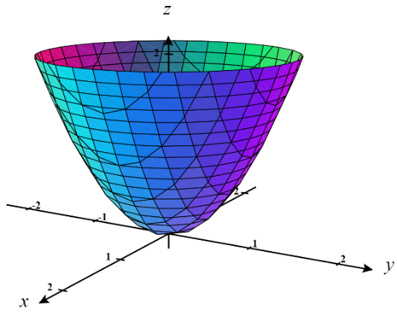
Since represents the graph of a function of the form we do not have to find a parameterization for and instead we tackle the problem as follows.

We note the function . Since the normal vectors here are facing upward we have:

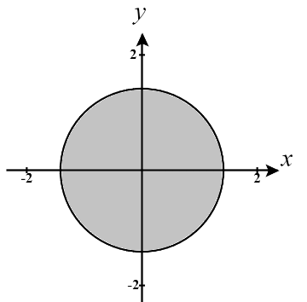
The region D is the projection of the solid into the xy-plane as shown in the picture to the right.

Therefore, we have that:

For the first integral we let which implies and the bounds become .
For the seconds integral we rewrite and then let which implies and the bounds become .
Therefore, we have that,

